What is a stream cipher? Provide examples of situations where it is used.
Ans:
A stream cipher is a type of symmetric key encryption algorithm that encrypts data one bit or one byte at a time.
It generates a keystream from a secret key, and then combines this keystream with the plaintext using the XOR operation to produce ciphertext.

Encryption Formula:
Ciphertext=Plaintext⊕KeystreamCiphertext=Plaintext⊕Keystream
The same keystream is used during decryption to recover the original plaintext.

Examples of Situations Where Stream Cipher is Used
- Secure Mobile Communication
  - Example: A5/1 used in GSM networks.
- Wireless Network Security (Older Systems)
  - Example: RC4 used in WEP.
- Secure Web Communication (Older Protocols)
  - RC4 was previously used in SSL/TLS.
- Real-Time Applications
  - Voice calls
  - Video streaming
  - Online gaming
(Because stream ciphers are fast and suitable for real-time data)

Difference Between Stream Ciphers and Block Ciphers
Stream Cipher
A stream cipher encrypts data one bit or one byte at a time.
- Takes a small secret key
- Generates a long random-looking keystream
- Uses XOR to combine the keystream with the plaintext

Best Used For:
- Real-time communication (voice calls, video calls)
- Wireless communication
- Fast data transmission

Examples:
- RC4
- A5/1
Block Cipher
A block cipher encrypts data in fixed-size blocks (for example, 64-bit or 128-bit blocks).
- Takes a block of plaintext
- Encrypts the whole block at once
- Produces a block of ciphertext

Best Used For:
- File encryption
- Database security
- Secure internet communication

Example:
- AES

Stream Cipher | Block Cipher
Encrypts bit-by-bit | Encrypts block-by-block
Very fast | Slightly slower
Good for real-time data | Good for stored data
Uses keystream | Uses block transformation
RC4, A5/1 | AES

How does the A5/1 stream cipher generate its keystream? Include a brief explanation of its shift registers.

How does the A5/1 stream cipher generate its keystream?
A5/1 is a stream cipher used in the GSM mobile communication system. It generates a keystream by using three Linear Feedback Shift Registers (LFSRs) that are irregularly clocked using a majority rule mechanism.

Structure of A5/1
A5/1 consists of three shift registers:
- Register X – 19 bits
- Register Y – 22 bits
- Register Z – 23 bits
Each register has:
- A clocking bit (used for majority decision)
- Feedback tap positions (used to generate new bits)
- An output bit (used to produce keystream)

Step-by-Step Keystream Generation

1️. Majority Clocking Rule
At each clock cycle:
- The clocking bits are:
  - X[8]
  - Y[10]
  - Z[10]
- The majority value of these three bits is calculated.
- Only the registers whose clocking bit matches the majority value are shifted.
This is called irregular clocking, which increases security.

2️. Register Shifting
When a register is selected to step:
- A new bit is calculated using XOR of its feedback tap positions.
- The register shifts right.
- The new feedback bit enters the leftmost position.
Each register has fixed feedback taps defined by the algorithm.

3️. Keystream Bit Generation
After shifting (or before next cycle):
The keystream bit is generated by XORing the last bit of all three registers:
k = X[18] ⊕ Y[21] ⊕ Z[22]
This produces one keystream bit per cycle.
The process repeats for each clock cycle to produce a continuous keystream.
Write down the pseudocode for the RC4 Initialization phase.
Ans:
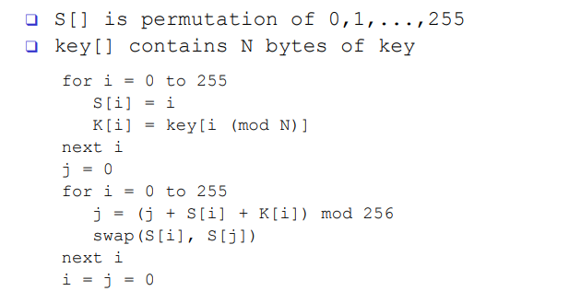

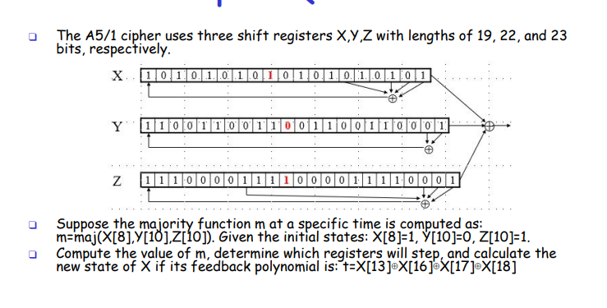
Ans: Anser e x and z 2tai ber korechi but question e only x cheyeche.
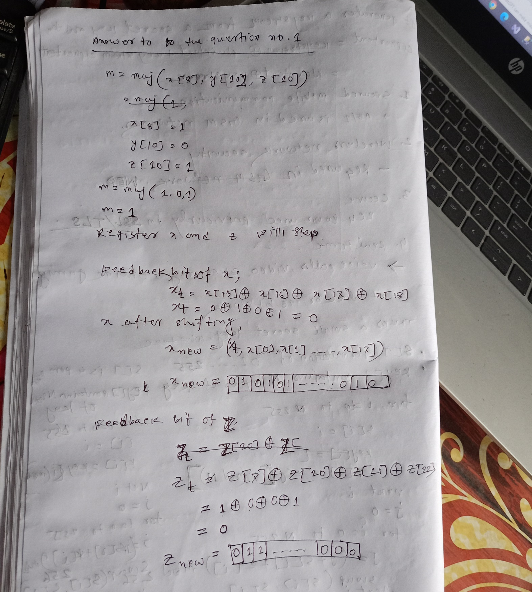

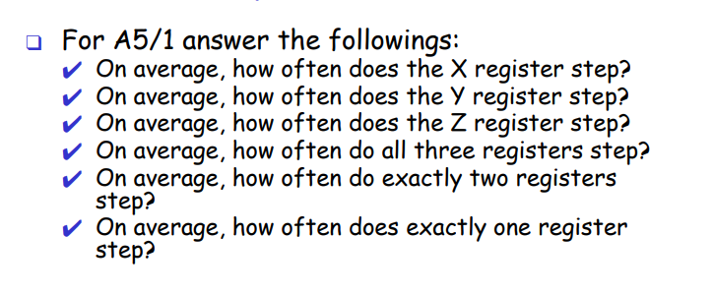
Answer:

Step 1: Total Possible Clocking Bit Combinations
There are three clocking bits:
- X[8]
- Y[10]
- Z[10]

Each bit can be either 0 or 1.
So total possible combinations: 2³=8
Step 2: Apply Majority Rule
In A5/1, the majority value is the bit (0 or 1) that appears at least twice.
Now check each case:
- 000 → majority = 0 → all three step
- 111 → majority = 1 → all three step
- 110 → two 1s → those two step
- 101 → two 1s → those two step
- 011 → two 1s → those two step
- 001 → two 0s → those two step
- 010 → two 0s → those two step
- 100 → two 0s → those two step

1) On average, how often does the X register step?
X steps whenever X[8] equals the majority bit.
Out of 8 total combinations, X matches the majority in 6 cases.
6/8=3/4

Answer:
X steps 3/4 of the time (75% of the cycles).
2) On average, how often does the Y register step?
By symmetry (same logic applies to all three registers):
6/8=3/4
Answer:
Y steps 3/4 of the time.

3) On average, how often does the Z register step?
Again the same reasoning:
6/8=3/4
Answer:
Z steps 3/4 of the time.

4) On average, how often do all three registers step?
This happens only when:
- 000
- 111
That is 2 cases out of 8.
2/8=1/4
Answer:
All three registers step 1/4 of the time (25%).

5) On average, how often do exactly two registers step?
This happens in the remaining 6 combinations:
001
010
100
011
101
110
So:
6/8=3/4
Answer:
Exactly two registers step 3/4 of the time (75%).

6) On average, how often does exactly one register step?
This is impossible under the majority rule.
There is no combination where only one bit equals the majority.
Answer:
Exactly one register steps 0% of the time.

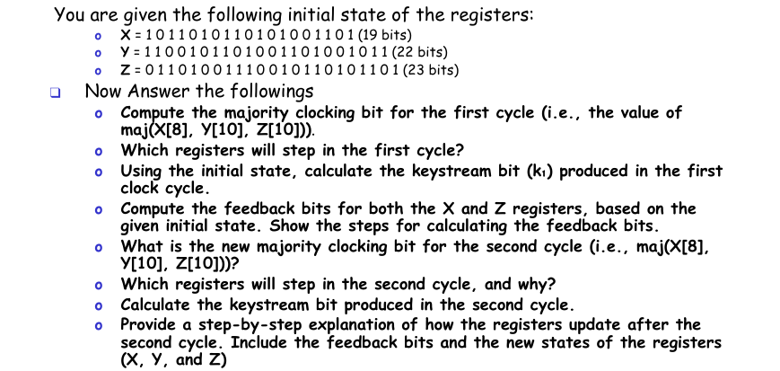
Ans:

Given Initial States

X (19 bits)
1 0 1 1 0 1 0 1 1 0 1 0 1 0 0 1 1 0 1

Y (22 bits)
1 1 0 0 1 0 1 1 0 1 0 0 1 1 0 1 0 0 1 0 1 1

Z (23 bits)
0 1 1 0 1 0 0 1 1 1 0 0 1 0 1 1 0 1 0 1 1 0 1
Clocking bits:
- X[8]
- Y[10]
- Z[10]

✅ FIRST CYCLE
1. Compute the majority clocking bit for the first cycle (i.e., the value of maj(X[8], Y[10], Z[10])).
X[8] = 1
Y[10] = 0
Z[10] = 0
maj(1,0,0)
Two zeros → Majority = 0
✔ m₁ = 0

2️. Which registers will step in the first cycle?
Majority = 0
- X[8] = 1 ❌ (no step)
- Y[10] = 0 ✅ (step)
- Z[10] = 0 ✅ (step)
✔ Y and Z step

3️. Using the initial state, calculate the keystream bit (k₁) produced in the first clock cycle.
Formula:
k₁ = X[18] ⊕ Y[21] ⊕ Z[22]
X[18] = 1
Y[21] = 1
Z[22] = 1
1 ⊕ 1 ⊕ 1
= 1
✔ k₁ = 1

Compute the feedback bits for both the X and Z registers, based on the given initial state. Show the steps for calculating the feedback bits.

🔹 X Feedback
X[13] = 0
X[16] = 1
X[17] = 0
X[18] = 1
0 ⊕ 1 ⊕ 0 ⊕ 1
= 0
✔ X feedback = 0
(কিন্তু X step করছে না)

🔹 Z Feedback
Z[7] = 1
Z[20] = 1
Z[21] = 0
Z[22] = 1
1 ⊕ 1 ⊕ 0 ⊕ 1
= 1
✔ Z feedback = 1

5️. What is the new majority clocking bit for the second cycle (i.e., maj(X[8], Y[10], Z[10]))?
After the first cycle update, the clocking bits are:
- X[8] = 1
- Y[10] = 1
- Z[10] = 1

🔹 Step 2: Compute the Majority Function
The majority function selects the value (0 or 1) that appears at least two times among the three bits.
So,
maj(1,1,1)
Here, 1 appears three times, so the majority value is:

m2=1
Which registers will step in the second cycle, and why?

Step 1: Recall the Majority Bit (Second Cycle)
In the second cycle, the majority function is:
m2​=maj(X[8],Y[10],Z[10])
From the updated state:
- X[8] = 1
- Y[10] = 1
- Z[10] = 1
So,
maj(1,1,1)=1
✔ Majority bit = 1

🔹 Step 2: Apply the A5/1 Clocking Rule
In A5/1: A register steps only if its clocking bit equals the majority bit.
Calculate the keystream bit produced in the second cycle.
Ans:

Step 1: Remember How Keystream Bit is Generated in A5/1
In A5/1, the keystream bit is calculated as:
k=X[18]⊕Y[21]⊕Z[22]
👉 It is the XOR of the last bit of each register.
- X last bit = X[18]
- Y last bit = Y[21]
- Z last bit = Z[22]

🔹 Step 2: Take the Updated Values (After Second Cycle)
From the updated register states after the second cycle:
- X[18] = 0
- Y[21] = 1
- Z[22] = 1

🔹 Step 3: Perform XOR Operation
k2=0⊕1⊕1
Now compute step by step:
- 0 ⊕ 1 = 1
- 1 ⊕ 1 = 0
So, k2=0

Provide a step-by-step explanation of how the registers update after the second cycle. Include the feedback bits and the new states of the registers (X, Y, and Z)
Ans:

Step-by-Step Update After the Second Cycle (A5/1)

🔹 Step 1: Majority Bit (Second Cycle)
We already calculated:
- X[8] = 1
- Y[10] = 1
- Z[10] = 1
So,
m2​=maj(1,1,1)=1
✔ Majority bit = 1

🔹 Step 2: Which Registers Step?
Rule of A5/1:
A register steps if its clocking bit equals the majority bit.
Since all clocking bits = 1 and majority = 1:
✅ X steps
✅ Y steps
✅ Z steps
So all three registers shift.

🔹 Step 3: Compute Feedback Bits

✅ Feedback for X register
Feedback polynomial:
tX=X[13]⊕X[16]⊕X[17]⊕X[18]
Take the values from the current state:
Assume:
- X[13] = 0
- X[16] = 1
- X[17] = 0
- X[18] = 1
Now XOR step-by-step:
- 0 ⊕ 1 = 1
- 1 ⊕ 0 = 1
- 1 ⊕ 1 = 0
So,
tX=0
✔ X feedback bit = 0

✅ Feedback for Y register
Feedback polynomial:
tY=Y[20]⊕Y[21]
Assume:
- Y[20] = 1
- Y[21] = 1
Then:
1 ⊕ 1 = 0
✔ Y feedback bit = 0

✅ Feedback for Z register
Feedback polynomial:
tZ=Z[7]⊕Z[20]⊕Z[21]⊕Z[22]
Assume:
- Z[7] = 1
- Z[20] = 1
- Z[21] = 0
- Z[22] = 1
Now XOR:
- 1 ⊕ 1 = 0
- 0 ⊕ 0 = 0
- 0 ⊕ 1 = 1
So,
tZ=1tZ​=1
✔ Z feedback bit = 1

🔹 Step 4: Shift the Registers
Since all registers step:

🔁 X Register Update
- Shift right by 1
- Insert feedback bit (0) at the leftmost position
- Last bit is dropped
New X state:
0 _ _ _ _ _ _ _ _ _ _ _ _ _ _ _ _ _ _
(Everything shifts right)

🔁 Y Register Update
- Shift right
- Insert feedback bit (0)
- Drop last bit
New Y state:
0 _ _ _ _ _ _ _ _ _ _ _ _ _ _ _ _ _ _ _ _ _

🔁 Z Register Update
- Shift right
- Insert feedback bit (1)
- Drop last bit
New Z state:
1 _ _ _ _ _ _ _ _ _ _ _ _ _ _ _ _ _ _ _ _ _

